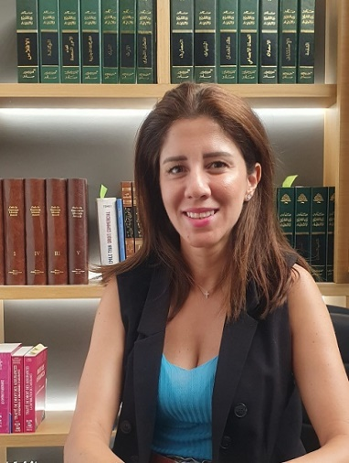 | RANIA MAOUAD  Compliance Consultant
 |  | +971 4 338 7880  +971 55 663 0539 |  |  | Abu Dhabi  C902 C6 Tower  King Abdulla Bin Abdul-Aziz Street  P.O. Box 61996  Abu Dhabi, United Arab Emirates
 |  | +971 4 338 7881
 |  | rania.maouad@bridgelg.com
 |  | www.bridgelg.com
 |  | Dubai  Sobha Sapphire Building, 4th Floor  Unit 404, Al Khaleej Al Tejari 2 Street Business Bay, Dubai  United Arab Emirates |  |  | Beirut  Stratum Office Building, 7th Floor  Omar Daouk Street, Mina El Hosn  Beirut Central District  Beirut, Lebanon
Rania Maouad holds a Master Degree in Management Studies from L’Ecole des Hautes Etudes Commerciales de Montréal–HEC (Canada) and a BA in Computer Engineering and Network Science from Saint Joseph University -USJ (Lebanon).
Ms. Moawad has a solid audit, risks and compliance experience capitalizing on 17 years work experience with the Lebanese Central Bank in analyzing financial institutions and their adherence to International Banking standards.
Ms. Moawad has a strong knowledge of banking and insurance risks. She regularly advises clients on cyber security, compliance and corporate governance matters. Ms. Moawad also works on special tasks covering the development of compliance policies and procedures, fraud investigations, financial due diligence, internal audit, operational performance improvements, risk management, Basel III rules, strategic solutions, self-assessment and third-party quality assurance.
Backed by her strong compliance and audit expertise, Ms Moawad heads BLG compliance team and acts as a Senior Compliance Consultant to a number of local and international companies operating in the UAE and the regional banking, financial and insurance sectors
Languages: Arabic, English, French.

